**YAHOO FINANCE USER GUIDE**

Yahoo Finance is a popular online platform that provides a wide range of financial news, data, and tools for investors, analysts, and anyone interested in financial markets.

**Accessing Yahoo Finance**

* **Website**: Go to [**yahoo.finance**](https://finance.yahoo.com)**.com.**
* **Mobile App**: Download the Yahoo Finance app from the App Store (iOS) or Google Play (Android).

**Navigating the Interface**

* **Home Page**: Displays market summaries, trending tickers, and top financial news.
* **Navigation Menu**: Located at the top of the page, includes sections like My Portfolio, Markets, News, and more.

### Market Data

#### Yahoo Finance provides real-time stock quotes for a wide range of stocks and also helps in viewing Historical Data

### News and Analysis

Helps in browsing latest financial news, market analysis, and expert insights.

### Portfolio Management

Click 'Create Portfolio' and enter a name for your portfolio. **Add stocks to your portfolio** and m**onitor performance** i.e. view overall portfolio performance, individual stock performance, and set up alerts.

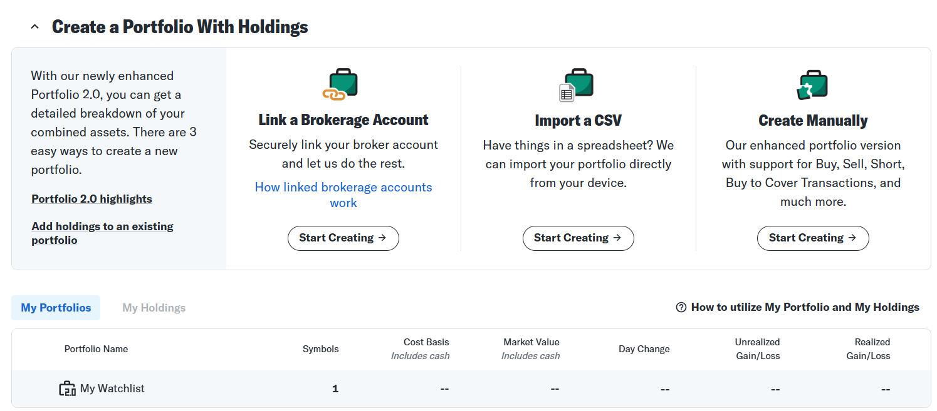

### Financial Statements

#### Accessing Financial Statements.

### Interactive Charts

### Provides interactive chart tools to compare with other stocks.

### Research Reports

Access detailed research reports and ratings from financial analysts.

### Community and Forums

#### Participating in Discussion Boards

Navigation Menu

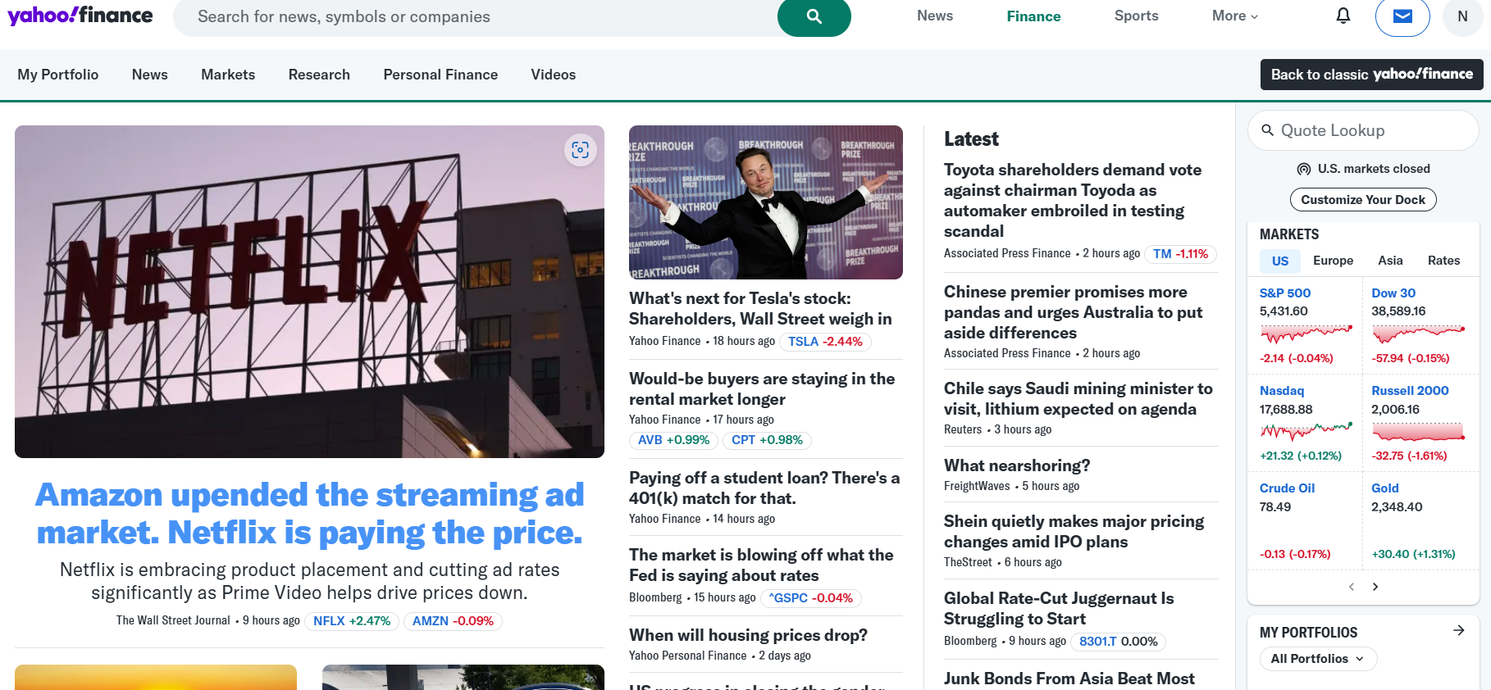



Latest News

SUMMARY OF THE COMPANY

* We can check the summary of the company by either searching for company name or ticker symbol by following steps:
* In the search bar at the top of the page, type the name or ticker symbol of the company you are interested in.
* Press Enter or click on the search icon.
* From the search results, click on the correct company name or ticker symbol to go to its stock page.
* The company’s stock page will open with the summary section displayed by default.
* The summary section provides key financial metrics and information about the stock.

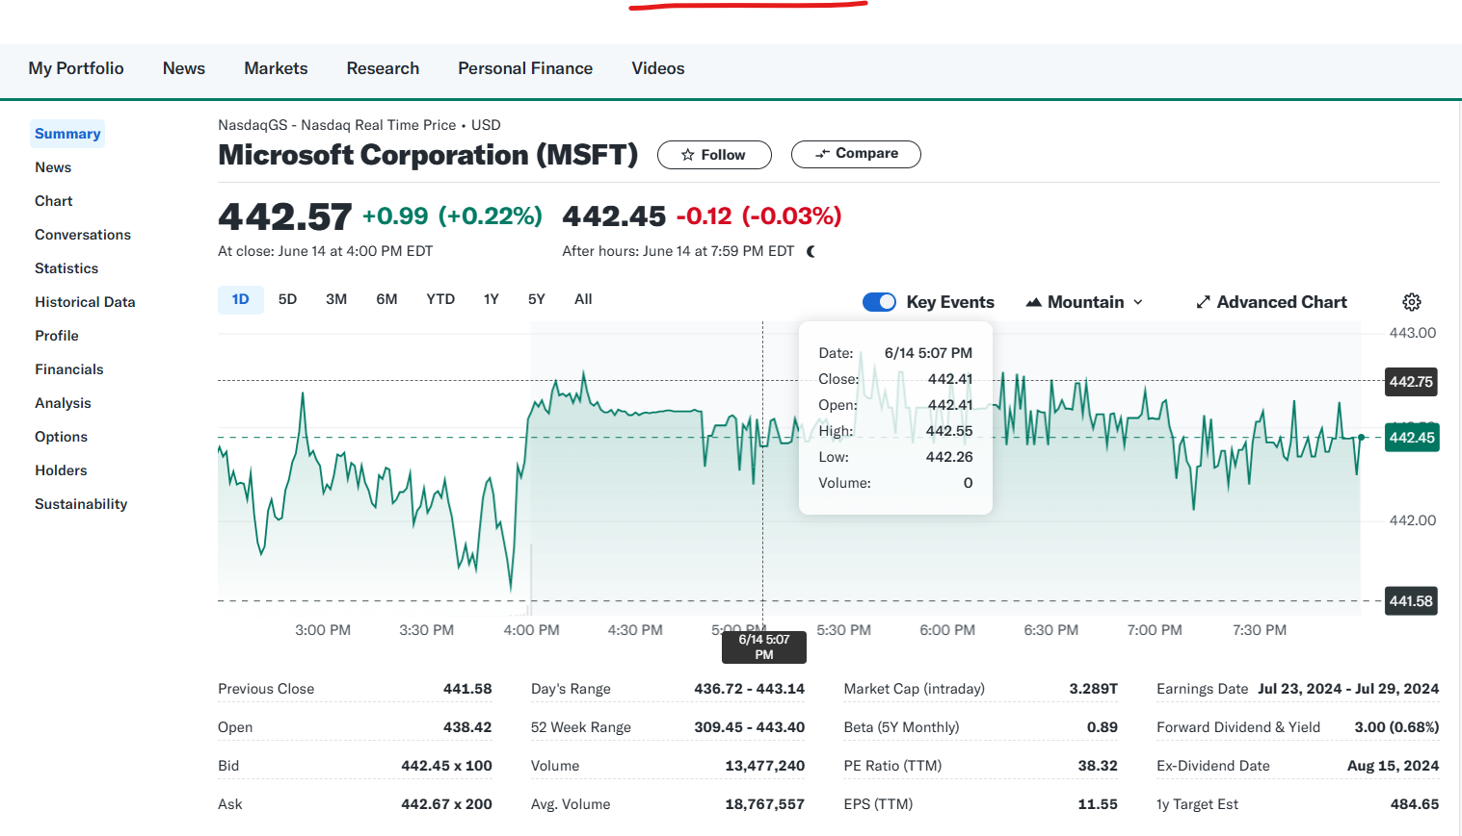

* Here is what you will typically find in the summary section:
* **Previous Close**: The last trading price of the stock on the previous trading day.
* **Open**: The price at which the stock started trading on the current day.
* **Bid**: The highest price a buyer is willing to pay for the stock.
* **Ask**: The lowest price a seller is willing to accept for the stock.
* **Day's Range**: The lowest and highest prices at which the stock has traded during the current trading day.
* **52 Week Range**: The lowest and highest prices at which the stock has traded over the past 52 weeks.
* **Volume**: The total number of shares traded during the current trading day.
* **Avg. Volume**: The average number of shares traded per day over a specified period (typically 30 days).
* **Market Cap**: The total market value of the company’s outstanding shares.
* **Beta**: A measure of the stock's volatility relative to the overall market.
* **PE Ratio (TTM)**: The price-to-earnings ratio calculated using the trailing twelve months earnings used to evaluate the valuation of a company's stock.

1. **Trailing P/E Ratio=**

**Current Stock Price / Earnings per Share (EPS) for the trailing 12 months**

1. **Current Stock Price**: The current market price per share of the company's stock.
2. **Earnings per Share (EPS)**: The total earnings of the company divided by the number of outstanding shares over the last 12 months.
3. **High P/E Ratio**: May indicate that the stock is overvalued or that investors expect high growth rates in the future.
4. **Low P/E Ratio**: May indicate that the stock is undervalued or that the company is experiencing difficulties.

* **EPS (TTM)**: Earnings per share over the trailing twelve months. It Indicates the company's profitability on a per-share basis.
* **Earnings Date**: The date on which the company is scheduled to release its next earnings report. Earnings reports can significantly impact the stock price, and investors often look forward to these dates.
* **Forward Dividend & Yield**: The total annual dividend expected to be paid per share and the dividend yield.
* **Ex-Dividend Date**: The cutoff date to be eligible for the next dividend payment. Investors need to own the stock before this date to receive the upcoming dividend.
* **1y Target Est**: The average price target estimated by analysts for the stock over the next year. Provides an expectation of the stock’s future price based on analysts’ forecasts.
* Other than summary section following information are provided as mentioned below:

### Statistics

* **Valuation Measures**: Includes metrics like market cap, enterprise value, trailing P/E, forward P/E, PEG ratio, price/sales, price/book, and enterprise value/EBITDA.
* **Financial Highlights**: Covers fiscal year and profit margin, operating margin, return on assets, return on equity, revenue, revenue per share, and quarterly revenue growth.
* **Balance Sheet**: Provides data on total cash, total cash per share, total debt, debt/equity, and current ratio.
* **Cash Flow**: Lists operating cash flow, levered free cash flow.

**2. Historical Data**

* **Stock Price History**: Historical stock prices, including open, high, low, close, adjusted close, and volume.
* **Download Options**: Data can be downloaded in CSV format for further analysis.

**3. Profile**

* **Company Overview**: Basic information about the company, including sector, industry, full-time employees, and business summary.
* **Key Executives**: Details about the company's executives, including their names, titles, ages, and compensation.

**4. Financials**

* **Income Statement**: Detailed income statements for the past several years, including revenue, gross profit, operating income, net income, and EPS.
* **Balance Sheet**: Detailed balance sheets, including total assets, total liabilities, and shareholders' equity.
* **Cash Flow**: Detailed cash flow statements, including operating cash flow, investing cash flow, and financing cash flow.

**5. Analysis**

* **Analyst Estimates**: Information on earnings estimates, revenue estimates, earnings history, EPS trend, and growth estimates.
* **Recommendation Rating**: Analysts’ ratings on the stock, including the number of buy, hold, and sell recommendations.
* **Earnings Estimates**: Future earnings estimates and the average target price set by analysts.

**6. Options**

* **Options Data**: Detailed options chain, including calls and puts with various expiration dates and strike prices.

**7. Holders**

* **Major Holders**: Information on institutional, mutual fund, and insider holdings.
* **Top Institutional Holders**: Lists the top institutional shareholders.
* **Top Mutual Fund Holders**: Lists the top mutual fund shareholders.
* **Insider Transactions**: Details recent transactions by company insiders.

**8. Sustainability**

* **ESG Scores**: Environmental, Social, and Governance (ESG) scores and ratings, which indicate how the company performs in these areas.
* **Sustainability Report**: Information and reports on the company’s sustainability practices.

**9. Chart**

* **Interactive Charts**: Interactive stock charts with various technical indicators, drawing tools, and comparison features.
* **Chart Settings**: Options to customize the chart's appearance, time frame, and indicators.

**10. News**

* **Latest News**: Recent news articles related to the company.
* **Press Releases**: Official press releases from the company.
* **Market News**: Broader market news that may impact the company’s stock
* It also provides the **Market Summary** in the following format:

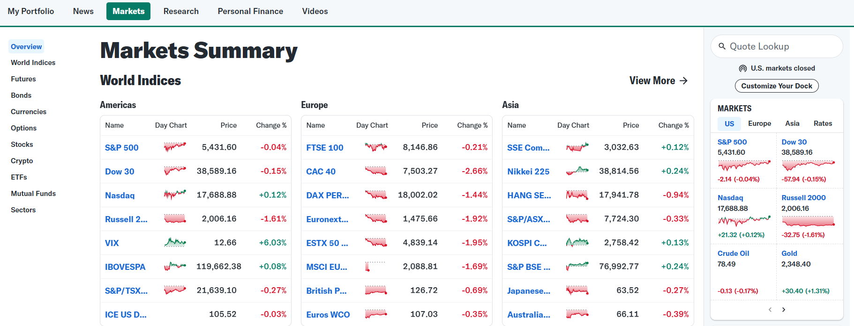

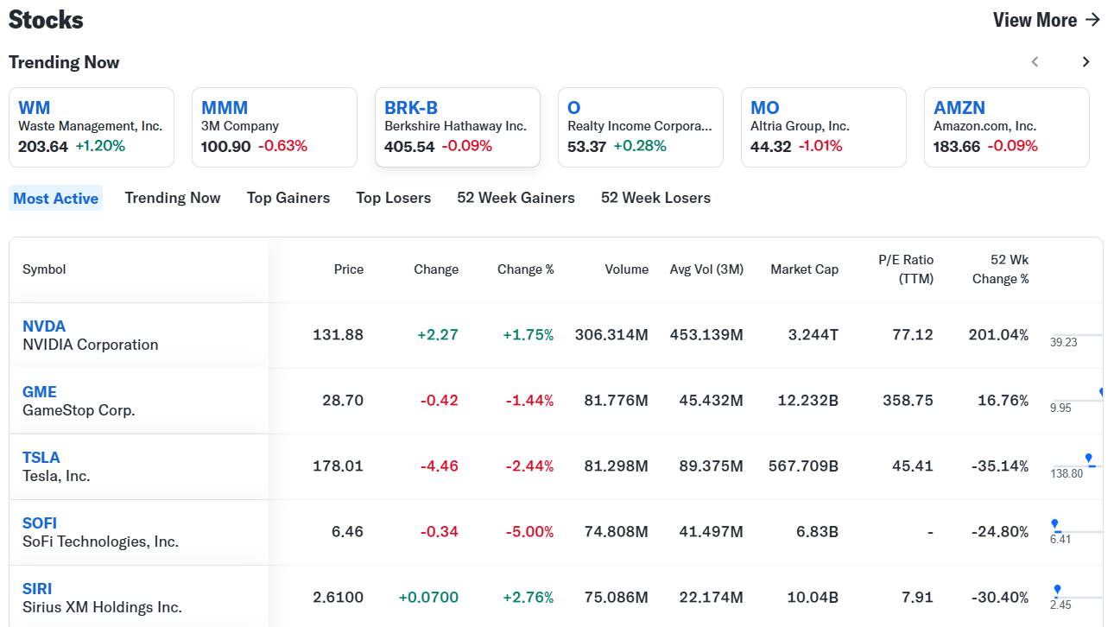

**Pros Of Yahoo Finance**

* Comprehensive market data and tools
* User-friendly and customizable interface
* Extensive news and analysis from various sources
* Effective portfolio management tools
* Free access with a broad range of features
* Active community and forums
* Educational resources and economic data
* Integration with other Yahoo services
* Social sentiment analysis
* Customizable notifications
* Global market coverage

**Cons Of Yahoo Finance**

* Ads and promotions can be distracting
* Basic tools may not meet the needs of advanced users
* Occasional data accuracy issues
* Mobile app limitations compared to the desktop version
* Security and data privacy concerns
* Lack of direct trading capabilities
* Potential bias from ad-financed model
* Interface clutter
* Inconsistent user experience across platforms
* Slow customer support response times
* No proprietary research reports
* Account vulnerability concerns

Some of the statistical information about the rise in user interaction on following basis are shown below:

|  |  |  |  |  |  |  |
| --- | --- | --- | --- | --- | --- | --- |
| **Year** | **Monthly Active Users (MAUs) (in millions)** | **Average Visit Duration (minutes)** | **Pages per Visit** | **Global Ranking (Finance Category)** | **Mobile App Downloads (millions)** | **Premium Subscribers (Estimated)(in lakhs)** |
| 2019 | 70 | 8.5 | 5.2 | Top 10 | 5 | N/A |
| 2020 | 80 | 9 | 5.5 | Top 10 | 8 | 1 |
| 2021 | 85 | 9.2 | 5.7 | Top 10 | 10 | 2 |
| 2022 | 90 | 9.5 | 6 | Top 10 | 12 | 3 |
| 2023 | 95 | 10 | 6.2 | Top 10 | 15 | 4 |

### BOTTOM LINE

Yahoo Finance is a convenient and accessible tool for obtaining financial data and news, especially for individual investors and casual users. However, for professional investors, analysts, or those requiring advanced features, the limitations in data accuracy, analytical tools, customization, and depth of information might necessitate the use of more robust financial platforms. Users should be aware of these limitations and consider supplementing Yahoo Finance with other resources or platforms to meet their specific needs.